Sulz am Neckar, December 2021

KIPP presents Indexing plungers for use in hygienically demanding application sectors

HEINRICH KIPP WERK has developed an indexing plunger that fulfils stringent hygiene requirements. Designed according to Hygienic DESIGN requirements, it prevents the adherence of dirt particles and eases the cleaning process. This makes the indexing plungers ideal for inclusion on machines and systems used in e.g. foodstuff and pharmaceutical industries and medical technology.

Indexing plungers enable rapid adjustment of movable machine components. Usually, with the help of a pull knob or ring, a pin is retracted from a counterpart so that a machine part can be moved to a desired position and then securely locked in place. KIPP now presents a structural component in Hygienic Design for application areas in which cleaning-friendly configuration plays an important role. The new indexing plungers made of high-quality 1.4404 stainless steel have a tapered collar so that the screw-in location can be hygienically sealed with the matching seal and shim washers. These components have a surface finish of Ra < 0.8 µm which prevents dirt particles from adhering. In addition, these indexing plungers are suitable for CIP/SIP cleaning processes.

The new indexing plungers in Hygienic Design made of FDA conform materials are resistant to polar and non-polar media as well as flavouring agents. They are available with or without a locking slot and with a hardened or non-hardened indexing pin. The indexing plungers are available with 6 and 8 mm indexing pins and with standard or fine M10 and M12 threads. The shaft seal is optionally available in 70 EPDM 291 (black) or 75 Fluoroprene® XP 41 (blue). A matching Hygienic USIT® seal and shim washer made of the same material is also supplied, this can also be obtained as an accessory if required, item No. K1491.

(Characters including spaces: 1,850)

Image overview:
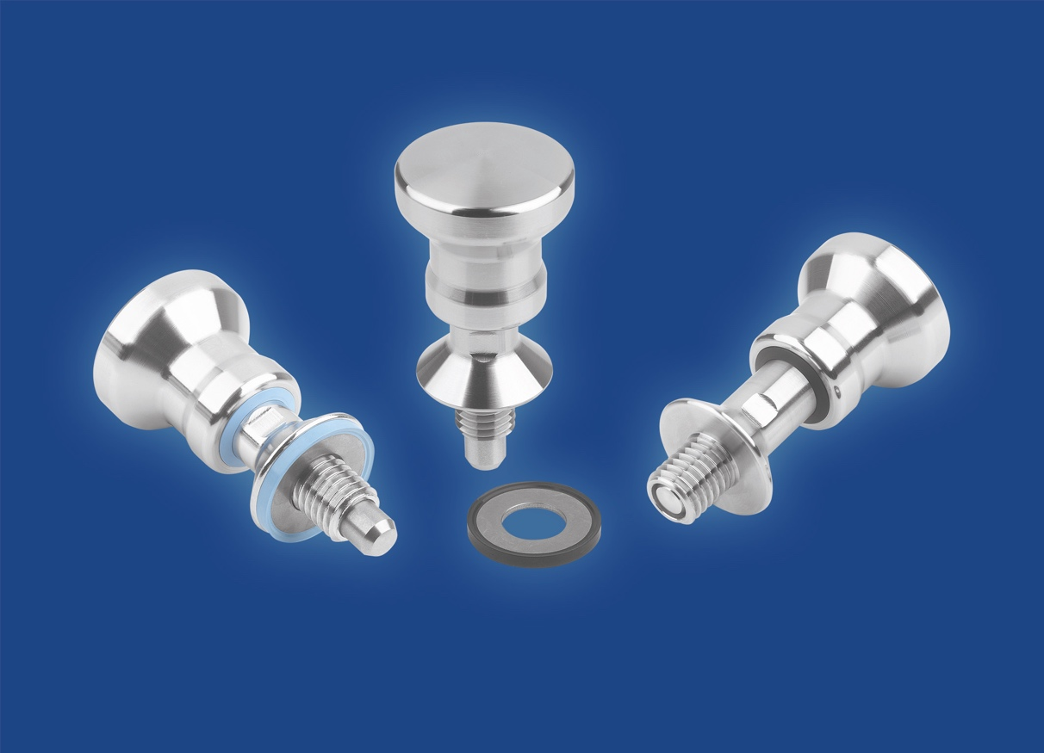

HEINRICH KIPP WERK is expanding its range to include stainless steel indexing plungers for hygienically demanding applications.
Image: HEINRICH KIPP WERK GmbH & Co. KG

HEINRICH KIPP WERK GmbH & Co. KG
Stefanie Beck, Marketing
Heubergstrasse 2
72172 Sulz am Neckar

Telephone: +49 7454 793-30
Email: stefanie.beck@kipp.com

